AN
INTERNSHIP REPORT
ON
CLINIC MANAGEMENT SYSTYM
PROJECT
BY
SASWATI MAHAPATRA

ABSTRACT
Clinic Management System is to automate the existing manual system by the help of computerized
equipments and full-fledged computer software, fulfilling their requirements, so that their valuable
data/information can be stored for a longer period with easy accessing and manipulation of the same. The
required software and hardware are easily available and easy to work with.
Clinic Management System, as described above, can lead to error free, secure, reliable and fast
management system. It can assist the user to concentrate on their other activities rather to concentrate on
the record keeping. That means that one need not be distracted by information that is not relevant, while
being able to reach the information.
The aim is to automate its existing manual system by the help of computerized equipments and
full-fledged computer software, fulfilling their requirements, so that their valuable data/information can be
stored for a longer period with easy accessing and manipulation of the same. Basically the project
describes how to manage for good performance and better services for the clients.

TABLE OF CONTENTS
Chapter 1
1. Introduction
1.1. Overview .................................................................................................
1.2. Objectives ..............................................................................................
1.3. Benefits of Existing System ................................................................
1.4. Identification of Needs ..........................................................................
Chapter 2
2. Survey of Technologies
2.1. Visual Studio Code .............................................................................
2.2. Languages ............................................................................................
Chapter 3
3.Requirement & Analysis
3.1SRS(Software Requirement Systems) ..................................................
3.2 Preliminary Investigation .....................................................................
3.3 Feasibility Study...................................................................................
3.4 System Analysis ...................................................................................
3.5 Hardware and Software Requirements ....................................................
3.6DFD ...........................................................................................................
3.6.1Context LevelDFD ........................................................................
3.6.2DFD Level 1 ..................................................................................
3.6.3DFD Level 2 ..................................................................................
3.7ER-Diagram .............................................................................................…
3.8Normalization ……………………………………………………………
3.9Flow Chart .......................................................................................…
3.10Gantt Chart ............................................................................................
Chapter 4
4.System Design
4.1Input to the project ....................................................................................
4.2Output to the project .................................................................................…

4.3Modularization details ...............................................................................…
Chapter 5
5.Program Code and Testing
5.1Code Details and Code Efficiency ..............................................................
5.2Testing Approach ...............................................................................
5.2.1Use Case ..............................................................................…
5.3Validation Check ...................................................................................
Chapter 6
6.Result and Discussion
6.1User Documentation ............................................................................
Chapter 7
7.Conclusion
7.1Limitations ..............................................................................
7.2Future cope ...........................................................................…
7.3Conclusion ..........................................................................…

Ch 1. INTRODUCTION
1.1. OVERVIEW
The "Clinic Management System" has been developed to override the problems
prevailing in the practicing manual system. This software is supported to eliminate
and in some cases reduce the hardships faced by this existing system. Moreover this
system is designed for the particular need of the company to carry out operations in a
smooth and effective manner. The application is reduced as much as possible to avoid
errors while entering the data. It also provides error message while entering invalid
data. No formal knowledge is needed for the user to use this system.
Thus by this all it proves it is user-friendly. Clinic Management System , as described
above, can lead to error free, secure, reliable and fast management system. It can
assist the user to concentrate on their other activities rather to concentrate on the
record keeping. Thus it will help organization in better utilization of resources. Every
organization, whether big or small, has challenges to overcome and managing the
information of Doctor, Clinic, Timeslot, Appointments, Calander.
Every Clinic Management System has different Clinic needs, therefore we design
exclusive employee management systems that are adapted to your managerial
requirements. This is designed to assist in strategic planning, and will help you ensure
that your organization is equipped with the right level of information and details for
your future goals. Also, for those busy executive who are always on the go, our
systems come with remote access features, which will allow you to manage your
workforce anytime, at all times. These systems will ultimately allow you to better
manage resources.
1.2. OBJECTIVES
The main objective of the Project on Clinic Management System is to manage the
details of Clinic, Doctor, Patient, Timeslot, Calander. It manages all the information
about Clinic, Appointments, Calander, Clinic. The project is totally built at
administrative end and thus only the administrator is guaranteed the access. The
purpose of the project is to build an application program to reduce the manual work
for managing the Clinic, Doctor, Appointments, Patient. It tracks all the details about
the Patient, Timeslot, Calander.
1.3. BENEFITS OF EXISTING SYSTEM
The project is identified by the merits of the system offered to the user. The merits of
this project are as follows: -
• Lack of security of data.

• More man power.
• Time consuming.
• Consumes large volume of pare work.
• Needs manual calculations.
• No direct role for the higher officials.
• User is provided the option of monitoring the records he entered earlier. He can
see the desired records with the variety of options provided by him.
1.4. IDENTIFICATIONOF NEEDS
The existing system is a manual one. After studying the problems of the existing
system, the following requirements have been identified.
The reasons behind need of development of movie rent master are:-
(A) Capability
(B) Movie rent activities are influenced by process transaction quickly and
efficiently.
(C) Automation is information system that adds capability of CD library in
three ways.
(1) Improved processing and speed CD library activities improve
processing speed in customer services & customer care.
(2) Increase volume: provide capacity to perform large amount of
transaction on large amount of record.
(3) Faster information retrieval: Locating and retrieving information
from storage in faster & efficient way.
(D) Control : The movie rent provides greater accuracy and consistency in
performing transaction.
(E) Reduce Costs: The CD library, which perform transaction faster & easily.
Movie rent reduce manpower requirement so ultimate effect is reduce cost
(F) Competitiveness : In competitive environment, organization requires
perform transaction faster, getting information timely, accurately so that
management can take decision quickly.
(G) Sharing of Information : The CD library system promotes the sharing of
information.




Ch 2. SURVEY OF TECHNOLOGY
2.1. SOFTWARE DESCRIPTION
Visual studio Code
Visual Studio Code combines the simplicity of a source code editor with
powerful developer tooling, like IntelliSense code completion and debugging.
First and foremost, it is an editor that gets out of your way. The delightfully
frictionless edit-build-debug cycle means less time fiddling with your
environment, and more time executing on your ideas.
Languages
HTML
HTML stands for Hypertext Markup Language. It allows the user to create
and structure sections, paragraphs, headings, links, and blockquotes for web
pages and applications.
HTML is not a programming language, meaning it doesn’t have the ability to
create dynamic functionality. Instead, it makes it possible to organize and
format documents, similarly to Microsoft Word.
CSS
Cascading Style Sheets, fondly referred to as CSS, is a simple design language
intended to simplify the process of making web pages presentable.
CSS handles the look and feel part of a web page. Using CSS, you can control
the color of the text, the style of fonts, the spacing between paragraphs, how
columns are sized and laid out, what background images or colors are used,
layout designs,variations in display for different devices and screen sizes as
well as a variety of other effects.
JavaScript
JavaScript is a dynamic computer programming language. It is lightweight and
most commonly used as a part of web pages, whose implementations allow
client-side script to interact with the user and make dynamic pages. It is an
interpreted programming language with object-oriented capabilities.



Ch 3. REQUIREMENTANDANALYSIS
3.1. SOFTWARE REQUIREMENTS SPECIFICATIONS
A software requirements specification is a document that captures complete
description about how the system is expected to perform. It is usually signed off at the
end of requirements engineering phase.
1. Product perspective: The software product is a Web application. The
application will be made up of two parts, one administrator who has all the
rights and the other user who has limited rights to handle the application. The
two users of the system, namely the Service Manager (Admin) and Customers
(User) interact with the system in different ways.
2. Product Functions: First of all, it will authenticate the user whether he is
Admin or User the unauthorized person can’t get access to the application.
The Admin will be able to Add, delete, and modify Product details. He can
also Add, delete and modify Service Request made by Customers.
3. Safety Requirements: All the data will be saved to database for safety
purpose so there will be no data loss. These data can be accessed only by an
authorized person so data theft is also not possible in this application.
4. Security | Requirements: | For | preventing | unauthorized | access | to | the
application, this application has login feature so only granted user can access
with defined rights.
5. System Analysis and Design: It refers to the process of examining a business
situation with the intent of improving it through better methods and
procedures. System Analysis is the process of gathering and interpreting the
facts, diagnosis the problems and using the information to recommend the
improvements to the replace or compliment an existing system.
6. Preliminary investigation: The system is investigated. The objective of this
phase is to conduct an initial analysis and findings of the system.
Requirement analysis
During this phase, all the relevant information is collected from the customer to
develop a product as per their expectation. Any ambiguities must be resolved in this
phase only.
Feasiblity study
To evaluate feasibility, a feasibility study is performed, which determines whether the
solution considered to accomplish the requirements is practical and workable in the
software. Information such as resource availability, cost estimation for software
development, benefits of the software to the organization after it is developed and cost
to be incurred on its maintenance are considered during the feasibility study. The

objective of the feasibility study is to establish the reasons for developing the software
that is acceptable to users, adaptable to change and conformable to established
standards.
3.2. PRELIMINARY INVESTIGATION
The First step in the system development life cycle is the preliminary investigation to
determine the feasibility of the system. The purpose of the preliminary investigation is
to evaluate project request. It is not a design study nor does it include it include the
collection of details to describe the system in all respect. Rather, it is the collection of
information that helps committee members to evaluate the merits of the project
request and make an informed judgment about the feasibility of the proposed project.
Request approval Preliminary Investigation in context of payroll system:-
Request clarification : Manual processing in institute takes more time in performing
task, and in manual system the chance of occurrence of errors are high ,and it
becomes more costly because a single task takes more organization cannot run
properly without getting accurate information. So institute also needs to be automated
by software. By using it the institute can work properly, timely & accurately.
Feasibility study: - The system is operational Feasible, technical feasible,
Economical Feasible as shown in feasible study, describe in Next section.
Request Approval: - Because the software development request is reasonable
employees. And it is technical, economical, perational feasible in all respect so the
project is improved. And the design work can be carried out.
3.3. FEASIBILITY REPORT
Feasibility is the determination of whether of not project is worth doing. The process
followed in making this determination is called feasibility study. The contents and
recommendation of such study will be used as sound basis for deciding whether to
proceed, postpone or called cancel the project. The most important feasibility that is
study by me about the automation of hotel is operational feasibility, technical
feasibility, and economic feasibility.
1. Operational feasibility Report :- In operational feasibility we determine
that proposed projects are beneficial only if they can be turned into
information system that will meet the operating system requirements of the
organization. This test of feasibility asks if the system works when it is
developed and installed.The Automation of hotel is operational feasible
because it can be turned into Automation of hotel work if it is developed and
installed.This system does not cause harm and the performance of staff
members will increase due to fast and reliable transaction service. it provides
simple and Good Looking Interface ( GUI Environment ) to it’s users.
2. Technical Feasibility Report :- These are number of technical issue,
which are generally raised during the feasibility stage of the investigation.

The automation of Hotel is technically feasibility because:-The Necessary
Technology (Hardware & Software like communication Line, Modem,
Network, Computer and Windows 9x) exist to developed and install
Automation of Hotel . The proposed equipment has the technical capacity to
hold the data required to the Automation of Hotel.It can be updated if
required. The system provides the technical guarantee of accuracy, reliability,
easy access and data security.
3. Economic Feasibility Report :- Automation of Hotel is Economic
feasibility because: Automation of Hotel does not required extra hardware
to installed it . It can be installed on the hardware that the institute using
currently. The cost of development Automation of Hotel is very low
comparison of cost of manual working By using manual method
performing each task many entries in registers. More manpower required,
occurrences of errors are high. Rechecking is required so the high cost
incurred in manual system. Automation of Hotel can be developed in
existing hardware & software o extra cost required.
3.4. SYSTEM ANALYSIS
After analyzing the requirements of the task to be performed, the next step is to
analyze the problem and understand its context. The first activity in the phase is
studying the existing system and other is to understand the requirements and domain
of the new system. Both the activities are equally important, but the first activity
serves as a basis of giving the functional specifications and then successful design of
the proposed system. Understanding the properties and requirements of a new system
is more difficult and requires creative thinking and understanding of existing running
system is also difficult, improper understanding of present system can lead diversion
from solution.
3.5. HARDWARE AND SOFTWARE REQUIREMENTS
Hardware Requirement :-
• | Processor | : | Pentium III 630MHz

• | RAM | : | 128 MB

• | Hard disk | : | 20 GB

• | Monitor | : | 15” color monitor

• | Keyboard | : | 122 keys
Software Requirement :-
• | Operating System | : | Windows 98, Windows XP, Windows7, Linux

• | Language | : | PHP Runtime Environment

• | Database : | MySQL Server

• | Browser | : | Any of Mozilla, Opera, Chrome etc

• | Web Server | : | Apache

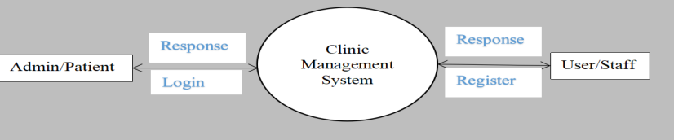

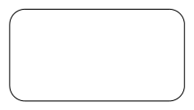


• | Software Development Kit : | PHP

• | Scripting Language Enable | : | Javascript

• | Database JDBC Driver | : | MySQL Jconnector
3.6 DATA FLOW DIAGRAM
DFD is an important tool used by system analysis. A data flow diagram
model, a system using external entities from which data flows through a
process which transforms the data and creates output data transforms which go
to other processes external entities such as files. The main merit of DFD is that
it can provide an overview of what data a system would process.
Symbols:
Process
Entity
Data Flow
Data Store
3.6.1. CONTEXT LEVEL DFD
3.6.2. LEVEL 1 DFD

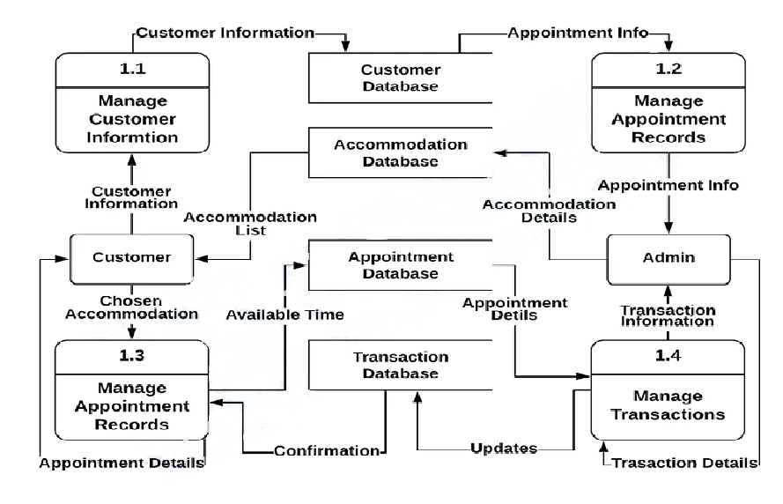
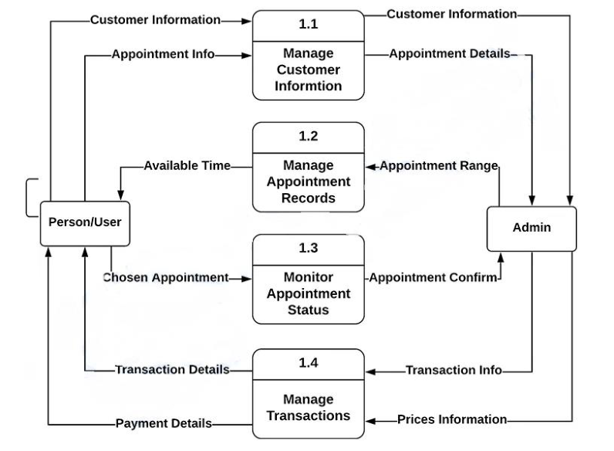

3.6.3. LEVEL 2 DFD

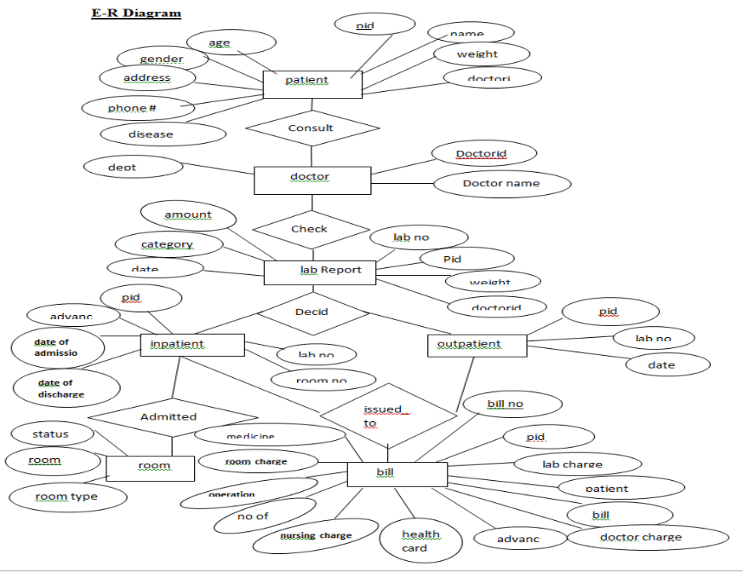
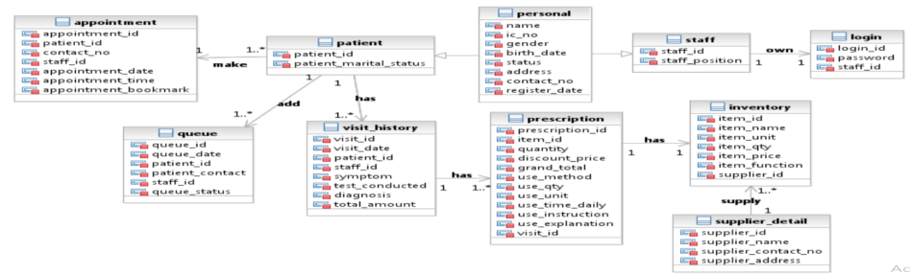

3.7. ER DIAGRAM

3.8. NORMALIZATION
UNF
System Details
COLUMN NAME
STAFF_ID | PATIENT_ADDRESS | SUPPLIER_NAME
STAFF_NAME | PATIENT_CONTACT_N  O | SUPPLIER_CONTACT _NO
STAFF_IC_NO | APPOINTMENT_ID | SUPPLIER_ADDRESS
STAFF_BIRTH_DATE | APPOINTMENT_DATE | TOTAL_AMOUNT
STAFF_ADDRESS | APPOINTMENT_TIME | QUANTITY
STAFF_CONTACT_NO | BOOKMARK | DISCOUNT_PRICE
STAFF_GENDER | QUEUE_ID | GRAND_TOTAL
STAFF_POSITION | QUEUE_DATE | USE_METHOD
STAFF_STATUS | QUEUE_STATUS | USE_QTY
LOGIN_ID, PASSWORD | VISIT_ID | USE_UNIT
PATIENT_ID | VISIT_DATE | USE_TIME_DAILY
PATIENT_NAME | SYMPTOM | USE_INSTRUCTION
PATIENT_IC_NO | TEST_CONDUCTED | USE_EXPLANATION
PATIENT_GENDER, | DIAGNOSIS
PATIENT_BIRTH_DATE | PRESCRIPTION_ID
PATIENT_MARITAL_STAT  US | ITEM_ID
PATIENT_REGISTER_DATE | ITEM_NAME
PATIENT_STATUS | ITEM_UNIT

1NF
Staff
Column Name | Data Type | Column Name | Data Type
STAFF_ID | Int (20) | STAFF_CONTACT_NO | Int (20)
STAFF_NAME | Varchar(50) | STAFF_GENDER | Varchar(5)
STAFF_IC_NO | Varchar(50) | STAFF_POSITION | Varchar(50)
STAFF_BIRTH_DATE | date | STAFF_STATUS | Varchar(50)
STAFF_ADDRESS | Varchar(50)

Patient Login
Column Name | Data Type
PATIENT_ID | Int (20)
PATIENT_NAME | Varchar(50)
PATIENT_IC_NO | Varchar(50)
PATIENT_GENDER | Varchar(50)
PATIENT_BIRTH_DATE | date
PATIENT_MARITAL_STATUS | Varchar(20)
PATIENT_REGISTER_DATE | date
PATIENT_STATUS | Varchar(50)
PATIENT_ADDRESS | Varchar(150)
PATIENT_CONTACT_NO | Int (20)

Column Name | Data Type
LOGIN_ID | Varchar(50)
PASSWORD | Varchar(50)
STAFF_ID | Varchar(50)
STAFF_POSITION | Varchar(50)
STAFF_NAME | Varchar(150)

QUEUE Visit History

Column Name | Data Type
QUEUE_ID |  | Int (20)
QUEUE_DATE |  | date
PATIENT_ID |  | Int (20)
PATIENT_NAME |  | Varchar(50)
PATIENT_CONTACT |  | Int (20)
STAFF_ID |  | Varchar(50)
STAFF_NAME |  | Varchar(250)
QUEUE_STATUS |  | Varchar(50)
Column Name | Data Type
VISIT_ID | Int (20)
VISIT_DATE | date
PATIENT_ID | Int (20)
PATIENT_NAME | Varchar(150)
STAFF_ID | Varchar(50)
STAFF_NAME | Varchar(150)
SYMPTOM | Varchar(50)
TEST_CONDUCTED | Varchar(50)
DIAGNOSIS | Varchar(50)
PRESCRIPTION_ID | Int (20)
TOTAL_AMOUNT | Varchar(50)

Prescription
Column Name | Data Type
PRESCRIPTION_ID | Int (20)
ITEM_ID | Int (20)
ITEM_NAME | Varchar(250)
ITEM_FUNCTION | Varchar(50)
ITEM_PRICE | Varchar(50)
QUANTITY | Varchar(250)
DISCOUNT_PRICE | Varchar(50)
GRAND_TOTAL | Varchar(50)

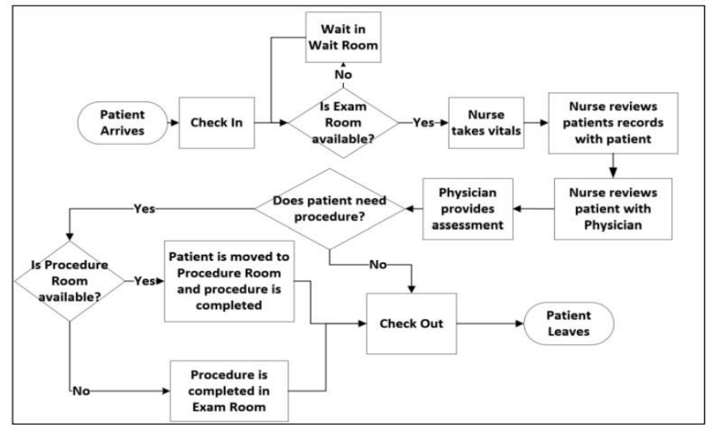

Inventory Supplier

Column Name | Data Type
ITEM_ID | Int (20)
ITEM_NAME
ITEM_UNIT
ITEM_QTY
ITEM_PRICE
Column Name | Data Type
SUPPLIER_ID | Int (20)
SUPPLIER_NAME
SUPPLIER_CONTACT_NO
SUPPLIER_ADDRESS

3.9. FLOW CHART
A flowchart is a diagram that depicts a process, system or computer algorithm. They are
widely used in multiple fields to document, study, plan, improve and communicate
often complex processes in clear, easy-to-understand diagrams. Flowcharts, sometimes
spelled as flow charts, use rectangles, ovals, diamonds and potentially numerous other
shapes to define the type of step, along with connecting arrows to define flow and
sequence.

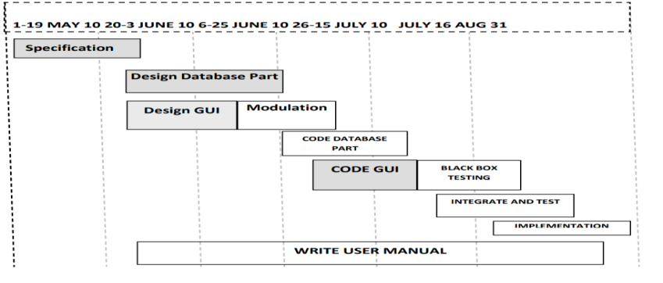

3.10. GANTT CHART
It is also known as Bar chart is used exclusively for scheduling purpose. It is a project
controlling technique. It is used for scheduling. Budgeting and resourcing planning. A
Gantt is a bar chart with each bar representing activity. The bars are drawn against a
time line. The length of time planned for the activity. The Gantt chart in the figure
shows the Gray parts is slack time that is the latest by which a task has been finished.

Ch.4. SYSTEM DESIGN
In this phase, a logical system is built which fulfils the given requirements. Design
phase of software development deals with transforming the clients’s requirements into
a logically working system. Normally, design is performed in the following in the
following two steps:
1. Primary Design Phase: In this phase, the system is designed at block level. The
blocks are created on the basis of analysis done in the problem identification phase.
Different blocks are created for different functions emphasis is put on minimising the
information flow between blocks. Thus, all activities which require more interaction
are kept in one block.
2. Secondary Design Phase: In the secondary phase the detailed design of every
block is performed.
The general tasks involved in the design process are the following:
1. Design various blocks for overall system processes.
2. Design smaller, compact and workable modules in each block.
3. Design various database structures.
4. Specify details of programs to achieve desired functionality.
5. Design the form of inputs, and outputs of the system.
6. Perform documentation of the design.
7. System reviews.
4.1 INPUT TO THE PROJECT
 All the fields such as Clinic, Patient, Calander are validated and does not take
invalid values .
 Each form for Clinic, Doctor, Appointments can not accept blank value fields
Avoiding errors in data.
 Controlling amount of input.
 Integration of all the modules/forms in the system.
 Preparation of the test cases.
 Preparation of the possible test data with all the validation checks.
 Actual testing done manually.
 Recording of all the reproduced errors.
 Modifications done for the errors found during testing.

 Prepared the test result scripts after rectification of the errors.
 Functionality of the entire module/forms.
 Validations for user input.
 Checking of the Coding standards to be maintained during coding.
 Testing the module with all the possible test data.
 Testing of the functionality involving all type of calculations etc.
 Commenting standard in the source files.
4.2. OUTPUT TO THE PROJECT
The development of the new system contains the following activities, which try to
automate the entire process keeping in view of the database integration approach.
1. User friendliness is provided in the application with various controls.
2. The system makes the overall project management much easier and
flexible.
3. There is no risk of data mismanagement at any level while the project
development is under process.
4. It provides high level of security with different level of authentication.
5. User friendliness is provided in the application with various controls.
6. The system makes the overall project management much easier and
flexible.
7. There is no risk of data mismanagement at any level while the project
development is under process.
8. It provides high level of security with different level of authentication.
4.3. MODULARIZATION DETAILS
➢ Clinic Management Module: Used for managing the Clinic details.
➢ Calander Module : Used for managing the details of Calander.
➢ Appointments Module : Used for managing the details of Appointments.
➢ Doctor Management Module: Used for managing the information and details of
the Doctor.
➢ Patient Module : Used for managing the Patient details.
➢ Timeslot Module : Used for managing the Timeslot information.
➢ Login Module: Used for managing the login details.
➢ Users Module : Used for managing the users of the system.

Ch 5. PROGRAM CODE AND TESTING
5.1. CODE IN HTML
<!DOCTYPE html>
<html>
<head>
<title>Clinic Management System</title>
<link rel="stylesheet" href="style.css">
</head>
<body>

<h1>Clinic Management System</h1>

<div class="form">
<input id="name" placeholder="Patient Name">
<input id="age" type="number" placeholder="Age">
<input id="disease" placeholder="Disease">
<button onclick="addPatient()">Add Patient</button>
</div>

<h2>Patients List</h2>
<ul id="list"></ul>

<script src="script.js"></script>
</body>
</html>

CODE IN CSS

body {
font-family: Arial;
background: #f4f6f8;
padding: 20px;
}

h1 {
color: #2c3e50;
}

.form input {
padding: 8px;
margin: 5px;
}

button {
padding: 8px 15px;
background: #3498db;
color: white;
border: none;
cursor: pointer;
}

li {
background: white;
margin: 5px;
padding: 10px;
}

CODE IN JAVA SCRIPT

body {
font-family: Arial;
background: #f4f6f8;
padding: 20px;
}

h1 {
color: #2c3e50;
}

.form input {
padding: 8px;
margin: 5px;
}

button {
padding: 8px 15px;
background: #3498db;
color: white;
border: none;
cursor: pointer;
}

li {
background: white;
margin: 5px;
padding: 10px;
}

5.2. TESTING APPROACH
Detailed Design of Implementation : This phase of the systems development life
cycle refines hardware and software specifications, establishes programming plans,
trains users and implements extensive testing procedures, to evaluate design and
operating specifications and/or provide the basis for further modification.
Technical Design : This activity builds upon specifications produced during new
system design, adding detailed technical specifications and documentation.
Test Specifications and Planning : This activity prepares detailed test specifications
for individual modules and programs, job streams, subsystems, and for the system as a
whole.
Programming and Testing : This activity encompasses actual development,
writing, and testing of program units or modules. User Training This activity
encompasses writing user procedure manuals, preparation of user training materials,
conducting training programs, and testing procedures.
Acceptance Test : A final procedural review to demonstrate a system and secure
user approval before a system becomes operational. Installation Phase In this phase
the new Computerized system is installed, the conversion to new procedures is fully
implemented, and the potential of the new system is explored.

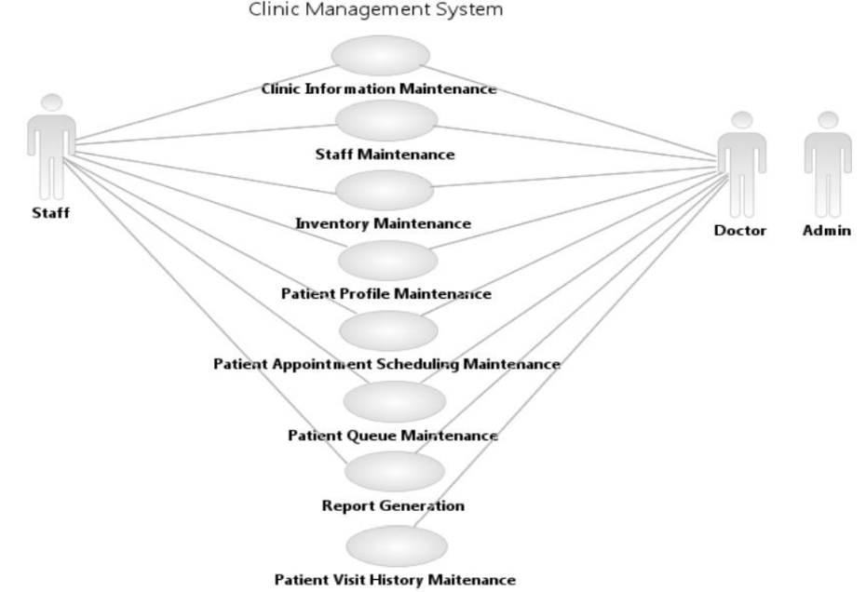
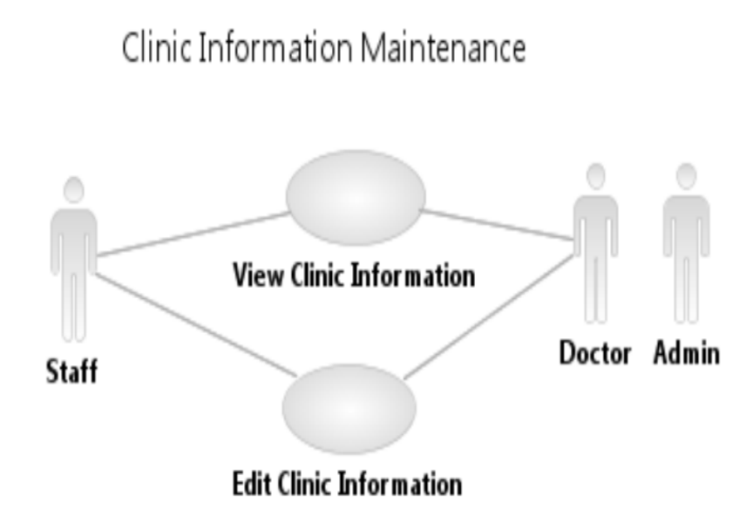

5.2.1 USE CASE DIAGRAM

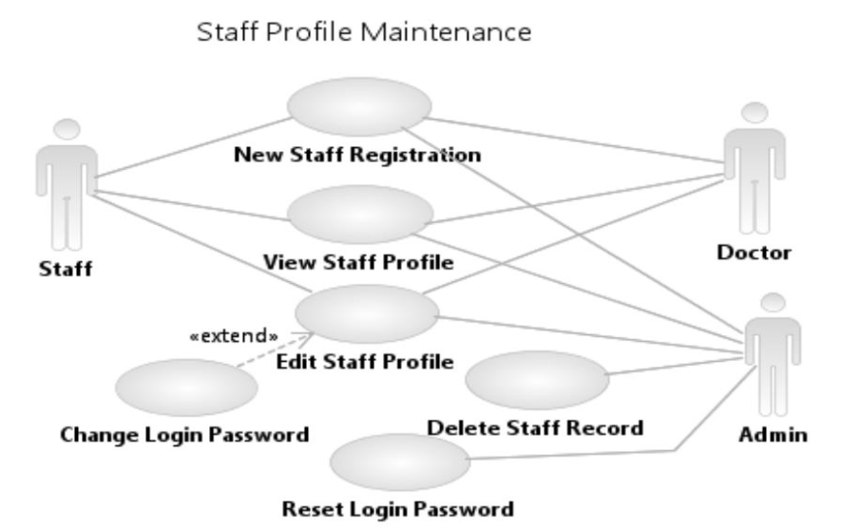
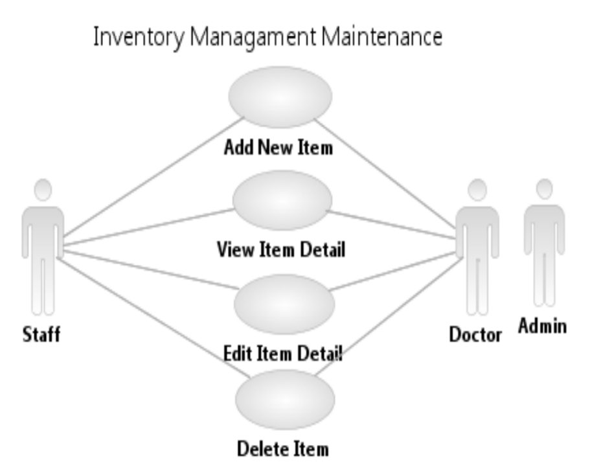

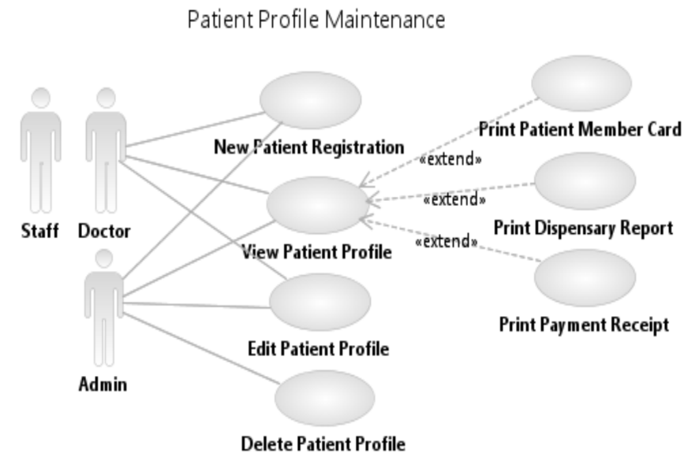
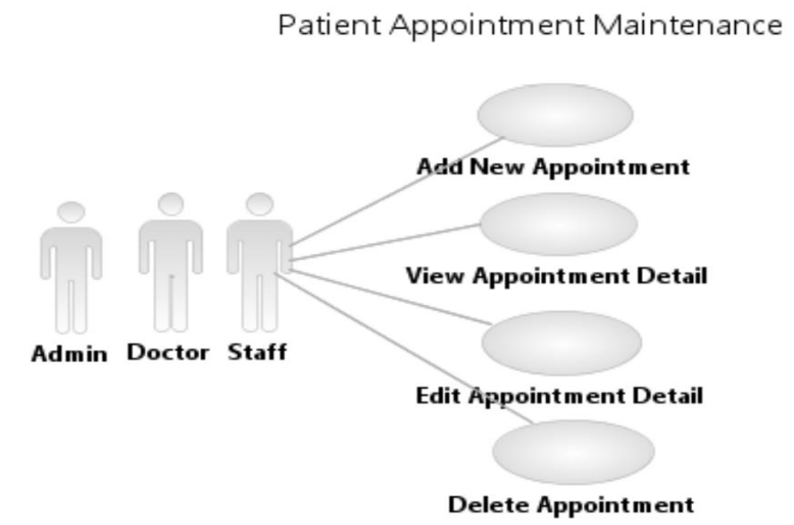

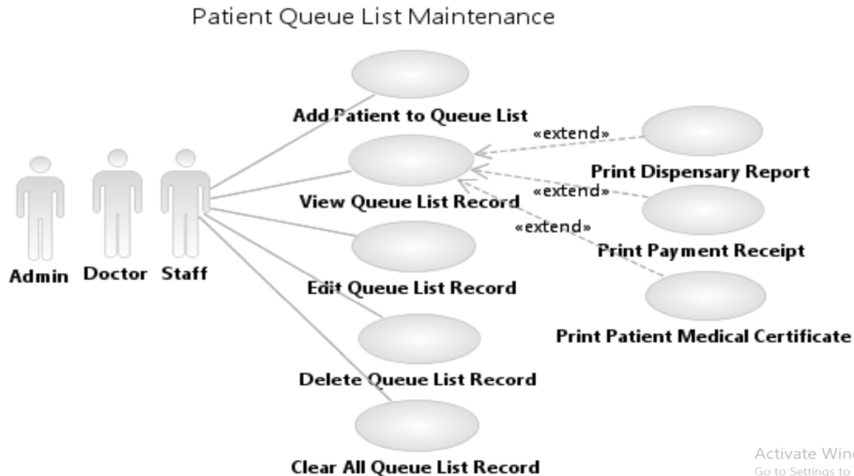
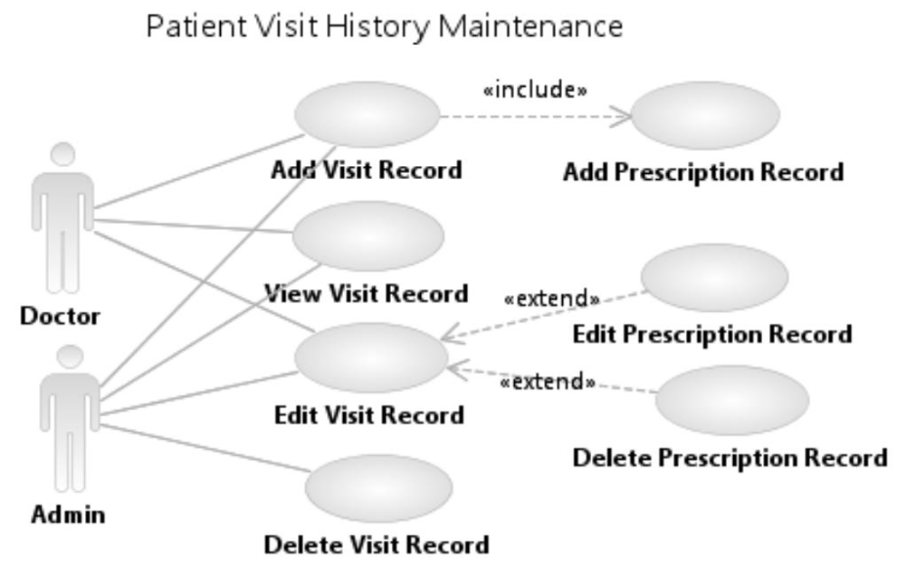

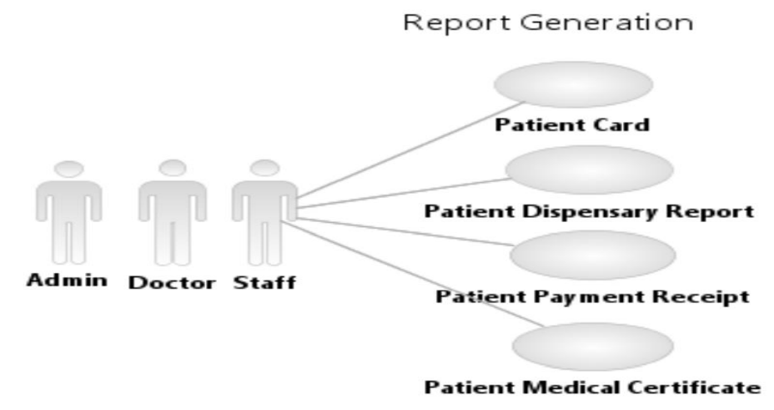

5.3. VALIDATION CHECK
Validation testing is one kind of testing which will test on whether the system is able to handle
the wrong data that entered by the user or not. It also use to ensure that the data entered by the
user is relevant and in the correct format or correct data types. For this testing, we will test
whether the system can handle the data that entered by the user.
For example, if the user is required to enter the numeric data but they are enter the string data,
will the system able to track the data entered by user and prompt error message to inform the
user to enter the correct one. This testing is very important because the wrong data entered may
cause the system error or accidentally insert the wrong data into the database and misleading the
system.

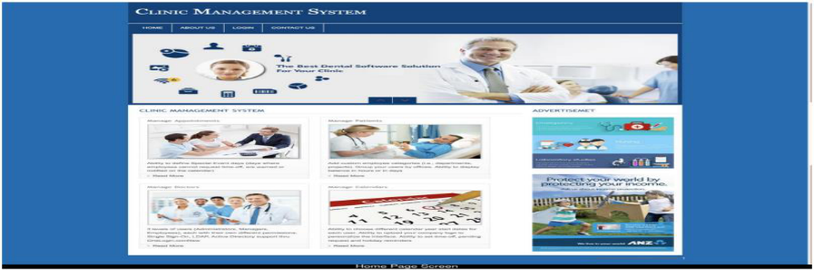
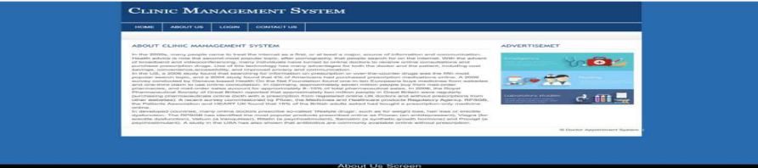
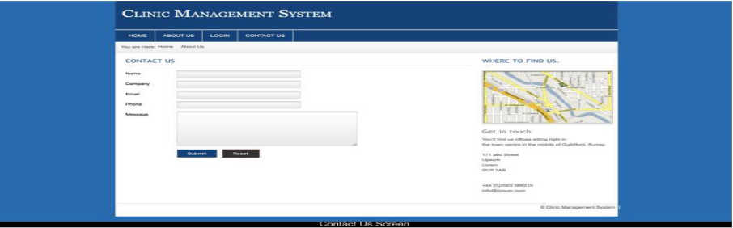
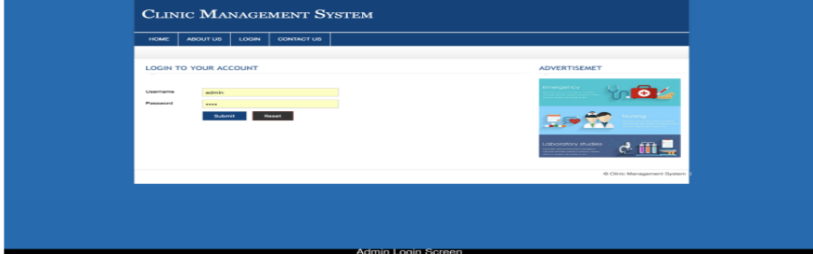

Ch 6. RESULTAND DISCUSSION
6.1 USER DOCUMENTATION

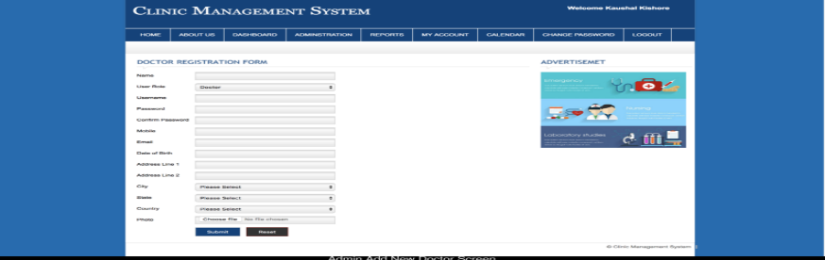
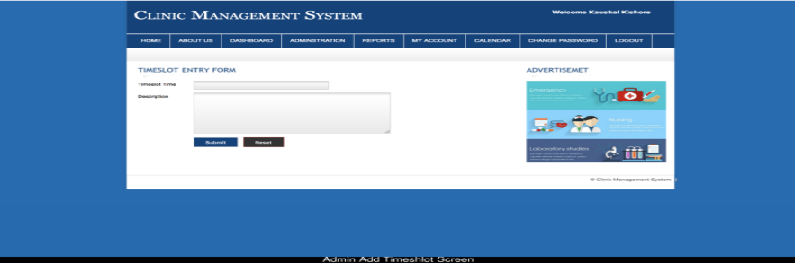
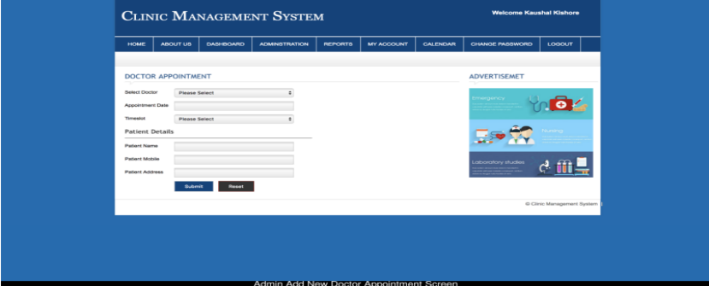
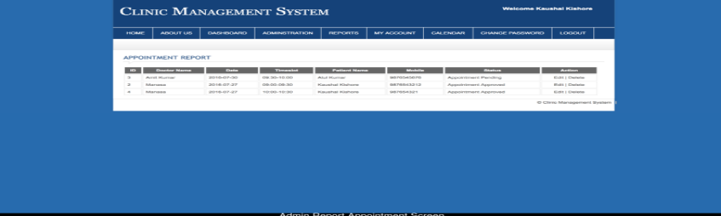

Ch 7. CONCLUSION
7.1. LIMITATIONS
• The size of the database increases day-by-day, increasing the load on the
database back up and data maintenance activity.
• | Training for simple computer operations is necessary for the | users working
on the system.
• It don’t have any industrial implementation, it is just applicable to be
implemented for small shops to main its shops products details and for
providing bills to the customer.
7.2. FURTHER SCOPE
• Some new features like charts, pipes, day to day sale can be added to the
existing system as per requirements.
• This project can be further customized and used other shops and stock
managements.
• Our project can be used in any shops and used for billing and keeping records
of the products as well. It is best way to keep the information and data
regarding products, vendor, customers for future aspects and saving time.
7.3. CONCLUSION
It has been a great pleasure for me to work on this exciting and challenging project.
This project proved good for me as it provided practical knowledge of not only
programming in PHP and MySQL web-based application. It also provides knowledge
about the latest technology used in developing web enabled application and client
server technology that will be great demand in future. This will provide better
opportunities and guidance in future in developing projects independently.

